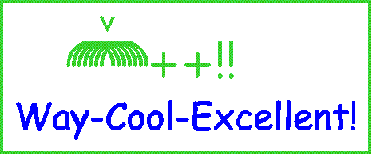



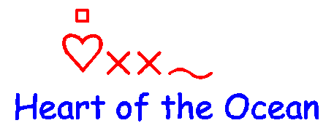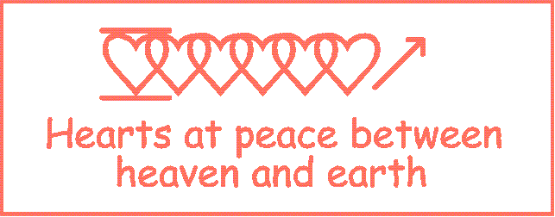
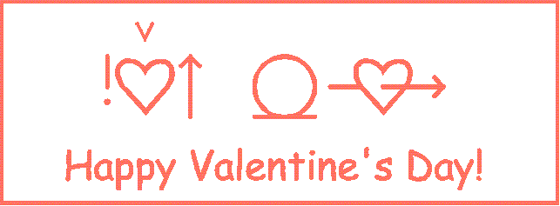
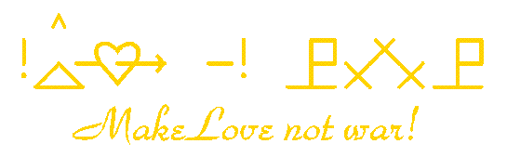
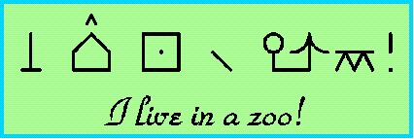
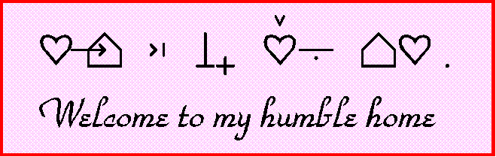

Bliss Symbols

Bliss symbols were developed by Charles Bliss and were originally created to help people who spoke different languages understand each other. I is more commonly used today for people with physical disabilities. They are often on a computer screen or a board. The person communicating in Bliss points to the symbol.

There are over 2000 symbols which have been translated for use in 32 different countries.

Some of the basic symbols are these:

putting symols together creates more words as you can see below:
eg tree + flower = park
Using the symbols in this booklet can you read the following message?

Using at least 4 symbols create your own message.

Have you ever seen anyone using Bliss symbols?

